Supermarket Sales Data

Introduction

Our dataset provides comprehensive insights into supermarket sales, capturing a wide array of variables. Fundamental transactional details include Invoice ID, Date, Time, and Payment Method. Additionally, it encompasses nuanced factors such as Branch Location, Customer Type, Gender Demographics, Product Line, and Product Ratings. This extensive documentation ensures a multifaceted understanding of sales dynamics, enabling detailed analysis of purchasing patterns, customer preferences, and demographic trends. The dataset's richness facilitates in-depth exploration and strategic decision-making based on a holistic view of the supermarket's operational and customer interaction landscape.

Key Attributes

- Invoice ID : This unique identifier for each sales transaction allows for easy tracking, auditing, and detailed analysis of individual purchases.

- Branch (A, B, C) : Indicates the supermarket's specific location, enabling the comparison of sales performance, customer behavior, and trends across different regions.

- Customer Type (Normal, Member) : Differentiates between regular and membership customers, providing insights into customer loyalty, purchasing patterns, and engagement levels.

- Gender (Male, Female) : Segments the customer base by gender, helping to understand and analyze purchasing preferences and trends between male and female shoppers.

- Product Line (Fashion Accessories, Electronic Accessories, Food and Beverages, Health and Beauty, Home and Lifestyle, Sports and Travel) : Groups products into categories, facilitating the analysis of sales performance, trends, and customer preferences across different types of merchandise.

- Unit Price, Quantity, Tax (5%) : Captures essential transaction details, crucial for calculating total revenue, understanding pricing impacts, and developing effective pricing strategies.

- 7. Payment Method (Credit Card, Cash, E-wallet) : Reflects the diverse payment options customers use, revealing trends and preferences in payment methods, which can guide future financial and operational strategies.

- Gross Margin Percentage, Gross Income, COGS : These performance metrics provide a comprehensive view of the supermarket's profitability, cost management, and overall financial health.

- Rating (1 to 10) : Represents customer feedback on products and services, offering valuable qualitative insights into customer satisfaction and areas needing improvement.

- City (Yangon, Mandalay, Naypyitaw) : Indicates the city where the transaction occurred, enabling geographical segmentation and analysis to understand market dynamics and regional performance differences.

Questionnaire

Q1. Which of the given cities having tax 5% slab performed better than all the others?
Q2. Which customer gender ordered most items from all the three branches?
Q3. Compare highest and lowest rating products on the basis of units sold.
Q4. Analyzing units sold and unit price data answer the following sub questions
- What is the degree of freedom?
- Co-relation of Unit price and revenue generated
- What result you can draw from regression of the two data

Q5. What product will you suggest as per the city data analysis to each type of customer?

Analytics

Q1. Which of the given cities having tax 5% slab performed better than all the others?
ANS: Based on the data analysis, Mandalay outperformed all other cities, showing superior performance in total sales and revenue generation within the same 5% tax slab. This highlights Mandalay's leading position in the supermarket's regional market dynamics.
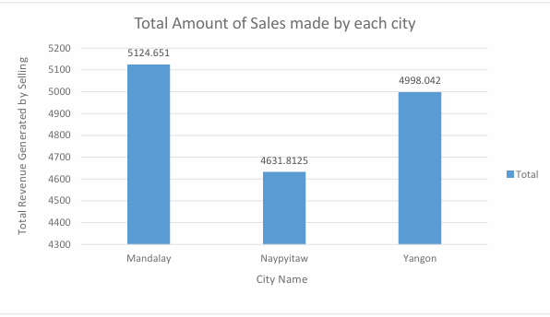

Q2. Which customer gender ordered most items from all the three branches?
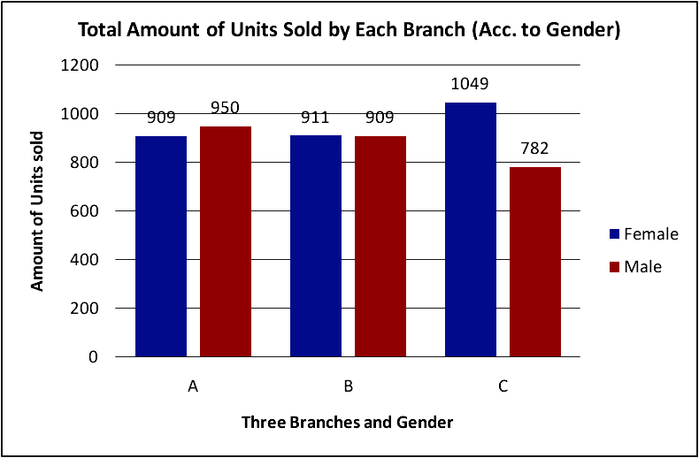

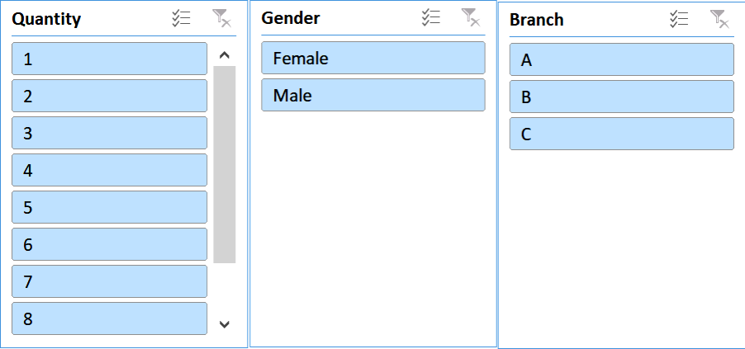

ANS: Our analysis of the Supermarket Sales Data revealed the following:

- Branch A : Females placed the highest number of orders.
- Branch B : Females also placed the highest number of orders.
- Branch C : Males placed the highest number of orders.

Q3. Compare highest and lowest rating products on the basis of units sold.

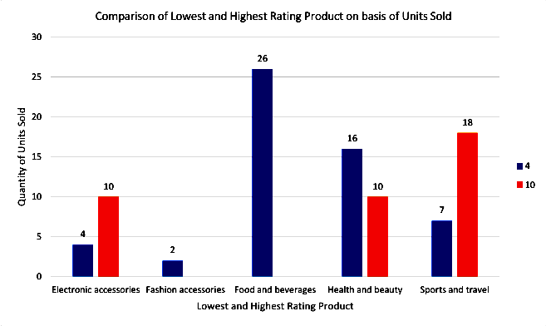

ANS: Upon analyzing the Supermarket Sales Data, product ratings were found to range from a minimum of 4 to a maximum of 10. The analysis revealed that higher-rated Electronic Accessories attracted more customer purchases, indicating a strong preference for quality in this category. In contrast, Fashion Accessories and Food and Beverages were predominantly composed of lower-rated products in customer purchases. Similarly, Health and Beauty products showed a tendency toward lower-rated items in customer preferences. However, in the Sports and Travel category, customers demonstrated a clear inclination to purchase higher-rated products, underscoring the importance of quality in their purchasing decisions.

Q4. Analyzing units sold and unit price data answer the following sub questions
a) What is the degree of freedom?
b) Co-relation of Unit price and revenue generated
c) What result you can draw from regression of the two data

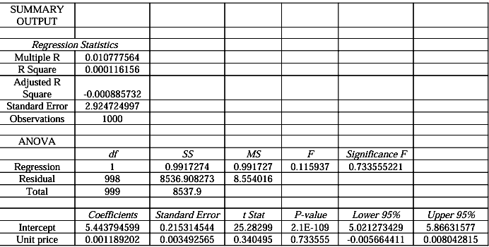

ANS: Upon scrutinizing the Supermarket Sales Data, several insights emerged:

a. The data exhibited a degree of freedom of 1, indicating the flexibility in analyzing trends.

b. A correlation of 0.63392 between unit price and generated revenue suggested a moderate positive relationship. The analysis, focusing on unit price and total revenue columns, employed the CORREL function.

c. Regression analysis aimed to uncover the correlation between quantity and unit price, revealing inconsistencies in customer purchasing behavior. Despite the trendline equation Quantity = 0.0012x + 5.4438, with a degree of freedom of 1, the coefficient of determination (R²) at 0.0001 underscored the lack of consistency in customer buying patterns solely based on unit price.

These findings illuminate the nuanced dynamics within the supermarket sales data. While certain correlations hint at trends, such as the positive relationship between unit price and revenue, others, like the inconclusive correlation between quantity and unit price, suggest complexities requiring further investigation for comprehensive understanding and informed decision-making.

Q5. What product will you suggest as per the city data analysis to each type of customer?
ANS: Based on the city data analysis, Food and Beverages emerge as an attractive option for Member-type customers, while Fashion Accessories are preferable for Normal-type customers. This strategic recommendation aligns product offerings with customer segmentation, optimizing sales opportunities and enhancing customer satisfaction based on their preferences and membership status.

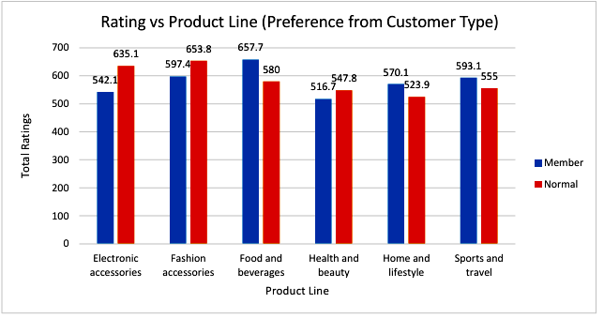

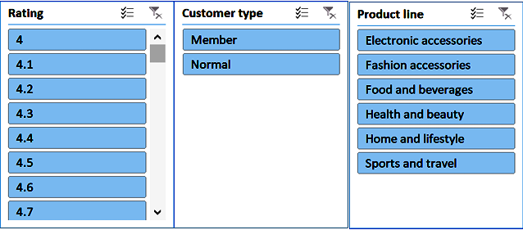

Conclusion

The comprehensive analysis of supermarket sales dynamics yields valuable insights into consumer behavior, operational trends, and performance metrics, guiding strategic decision-making. Mandalay emerges as the top-performing city in the 5% tax slab, offering a lucrative market for supermarket businesses. Gender-specific ordering trends reveal females favor Branch A, while males dominate Branch C, emphasizing the importance of targeted marketing. Further examination of product ratings and units sold is crucial for inventory management and marketing decisions. Regression analysis indicates a weak correlation (R² = 0.0001) between unit price and quantity sold, suggesting complex factors influencing customer purchasing decisions beyond price alone. Based on city data analysis, Food and Beverages are recommended for member-type customers, while Fashion Accessories suit normal customers, aligning product offerings with observed preferences. These conclusions underscore the significance of data-driven insights in optimizing sales strategies and enhancing customer satisfaction.

Review

The report offers a comprehensive examination of supermarket sales dynamics, delving into critical aspects like city performance, gender-based ordering trends, and product recommendations. The incorporation of regression analysis enriches the depth of insights, yet additional interpretation of results could bolster analytical robustness. To enhance clarity and comprehension, the inclusion of clear visuals such as graphs and charts would elucidate complex relationships, improving the presentation of findings. Overall, the report provides invaluable insights for stakeholders in the supermarket industry, pinpointing areas for strategic emphasis and enhancement in marketing and operational strategies. By highlighting trends and preferences among different customer segments and cities, the report serves as a valuable resource for informed decision-making, guiding efforts to optimize sales performance and customer satisfaction. With further refinement in analytical techniques and visual presentation, future iterations of the report have the potential to offer even greater depth and utility to stakeholders seeking to navigate the complex landscape of supermarket sales.

